SVKM’s NMIMS University
(Deemed-to-be University)

MUKESH PATEL SCHOOL OF TECHNOLOGY
MANAGEMENT & ENGINEERING (MPSTME) Vile Parle (W), Mumbai-56

Autonomous Fire Extinguishing Robot
Project Report submitted in the partial fulfilment
of
Bachelor of Technology
IN
Electronics and Telecommunication Engineering
by
Pranav Lavande-D040, Soham Surve-D056, Tanisha Bhatnagar-D071

Under the supervision of
Prof. Ketki Deshmukh
(Designation, Name of the department, MPSTME)

CERTIFICATE


This is to certify that the project entitled (“Autonomous Fire Extinguishing Robot”), has been done by Pranav Lavande, Soham Surve, Tanisha Bhatnagar under my guidance and supervision & has been submitted in partial fulfilment of the degree of BTECH in EXTC of MPSTME, SVKM’s NMIMS (Deemed-to-be University), Mumbai, India.

_____________________
Prof. Ketki Deshmukh ___________________________________
Project mentor (name and Signature) Examiner ( name and Signature) (Intenal Guide)
Date
Place: Mumbai Dr.Avinash More_____________
(HoD) (name and Signature)

ACKNOWLEDGEMENT

Student Names

NAME | ROLL NO. | SAP ID
Pranav Lavande | D040 | 70062200029
Soham Surve | D056 | 70062200007
Tanisha Bhatnagar | D071 | 70062200099

ABSTRACT

Sensitive environments such as server rooms, labs, and control centers contain delicate electronic equipment vulnerable to fire. Traditional fire suppression methods pose a significant challenge; water-based systems risk causing catastrophic collateral damage and halting operations, while gas-based systems are often expensive, delayed in activation, and lack precision. This creates a critical need for an autonomous, non-invasive, and targeted fire suppression system that can protect high-value assets without disrupting operations or causing collateral damage.
This project, "Autonomous Fire Extinguishing Robot," introduces an intelligent and precision-focused approach to this challenge. The proposed solution is an advanced robotic system capable of identifying and extinguishing fires without harming equipment. The model operates on a comprehensive four-stage operational cycle to prevent, detect, and suppress fires. In the ANALYZE stage, the system constantly logs and monitors data from multiple sensing modules, including smoke, gas, and temperature, which is transferred to the vehicle over the network. In the DETECT stage, if sensor data crosses a predefined threshold, the robot navigates to the source and uses onboard thermal cameras to confirm a credible threat, a multi-sensor approach that minimises false positives. Once confirmed, the RESPOND stage involves activating a precision trigger to deploy a non-damaging, electrically safe extinguishing agent directly at the source. This is followed by the deployment of sand to protect the vehicle's tires and, if temperatures exceed 250°C, the release of fire extinguishing balls. Finally, in the REPORT stage, all incident data, including sensor readings and multiple video feeds (capturing autonomous navigation and extinguishing actions), is logged to a central dashboard for post-incident analysis and to allow for remote operation.
The system is being developed using an agile methodology and a modular architecture. A fully functional, compact, and maneuverable prototype has been built, incorporating a specialized chassis with strategically placed openings for optimal sensor exposure and internal cooling, for validation in a simulated environment. Initial testing has demonstrated a detection speed for simulated smoke and gas of less than 10 seconds, which is significantly faster than human response time. The salient contribution of this work is its unique multi-stage suppression system, a feature not implemented in referenced prior works. The ultimate vision is to redefine safety and ensure operational continuity within critical infrastructure.

TABLE OF CONTENTS

Chapter 1- Introduction
1.1 Background of the Project Topic
1.2 Motivation and Scope of the Report
1.3 Problem Statement
1.4 Salient Contribution
1.5 Organization of Report
Chapter 2- Literature survey
2.1 Introduction to the Topic
2.2 Literature Survey and Identification of Research Gap
Chapter 3- Methodology and Implementation
3.1 Block diagram
3.2 Hardware description
Chapter 4- Result and Analysis
Chapter 5- Advantages, Limitations and Applications
5.1 Advantages
5.2 Limitations
5.3 Applications
Chapter 6- Conclusion and Future Scope
References
Appendix A: Soft Code Flowcharts
Appendix B: List of Paper Presented and Published

LIST OF FIGURES
Fig No | Name of the figure | Page No
1 | Fire in server room | 8
3.1 | Algorithm Flow Diagram | 22
3.2 | Circuit Block Diagram | 23
4 | Motor-120RPM Brushed DC | 24
5 | MD20A | 25
6 | Arduino UNO | 26
7 | Node MCU(ESP8266) | 26
8 | MG996R Servo | 27
9 | 3 Cell Lipo Battery | 28
10 | ZED-21 STEREO Camera | 29
11 | 7000RPMS Server Fan | 30
12 | 4 Channel Relay | 30
13 | ROS Published Data | 34
14

ABBREVIATIONS

Chapter 1: Introduction

1.1 Background of the project topic
Modern society relies heavily on critical infrastructure like data centers, server rooms, laboratories, and control centers. These environments are characterized by a high density of delicate, high-value electronic equipment that is extremely sensitive to environmental conditions. A fire in such a facility can lead to catastrophic financial losses, data loss, and severe operational downtime. Consequently, effective fire detection and suppression systems are paramount.
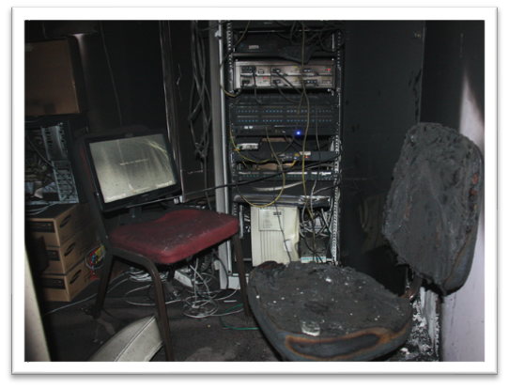
However, traditional fire suppression systems present a significant dilemma. Water-based sprinkler systems, while effective for common fires, are disastrous for electronic equipment, causing irreversible damage through short circuits and corrosion.
Figure 1: Fire in server room
Gaseous suppression systems (e.g., clean agents like Novec 1230 or FM-200) are a better alternative but come with their own drawbacks. They are often expensive to install and maintain, can be delayed in activation, and typically flood an entire room, lacking the precision to tackle a localized fire source. This lack of precision means that even a small, isolated incident can trigger a full system discharge, leading to unnecessary cost and operational halts.
The field of robotics and artificial intelligence offers a promising alternative. Autonomous systems can provide a rapid, intelligent, and targeted response that traditional systems cannot. By integrating advanced sensors, mobility, and intelligent decision-making, an autonomous robot can navigate to the precise location of a fire and deploy an appropriate extinguishing agent without affecting surrounding equipment. This project, the "Autonomous Fire Extinguishing Robot," is situated at the intersection of robotics, IoT, and fire safety, aiming to develop an intelligent system that redefines safety and operational continuity in these critical environments

1.2 Motivation and scope of the report

Motivation
The primary motivation for this project is to address the critical gap left by current fire suppression technologies in sensitive environments. The core drivers are:
• Asset Protection: Industries such as finance, healthcare, and IT stand to lose millions of dollars in mission-critical equipment from a single fire incident. The motivation is to create a solution that extinguishes fires without causing collateral damage to these high-value assets.
• Operational Continuity: Traditional systems often require a complete shutdown of operations. An autonomous, targeted system can neutralise a threat locally, allowing the rest of the facility to remain operational, thereby ensuring business continuity.
• Market and Regulatory Demand: The global market for data center fire detection and suppression is projected to exceed $2 billion, indicating a strong industry demand for innovative solutions. Furthermore, stricter safety regulations and the potential for reduced insurance premiums create powerful incentives for adopting advanced, less-damaging systems.

Scope
The scope of this project is the design, development, and validation of a prototype for an autonomous fire extinguishing robot refined for indoor, electronics-sensitive zones. The project encompasses:
1. System Design: Developing a compact, manoeuvrable rover featuring a specialised chassis with strategically placed top holes, side holes, and slits for sensor exposure and ventilation. The design is modular, allowing for independent development and testing of its core components.
2. Intelligent Sensing and Detection: Integrating a multi-sensor array (smoke, gas, temperature) with onboard thermal cameras to achieve rapid and accurate fire detection while minimising false positives. The communication protocol for sensor data transfer is based on the IEEE 802.11 (Wi-Fi) standard.
3. Autonomous Navigation and Response: Implementing an autonomous algorithm for navigation that includes reaching specific sensor locations, obstacle avoidance, and identifying the burning server using machine learning, as demonstrated in autonomous navigation video feeds (Autonomous vid).
4. Multi-Stage Suppression Mechanism: Designing and integrating a unique, layered extinguishing system featuring a precision extinguisher trigger. This system, validated via extinguisher video (Extinguisher vid), deploys sand, a non-damaging clean agent (CO₂/DCP), and fire extinguishing balls in a sequential, context-aware manner.
5. Reporting and Monitoring: Creating a central dashboard for logging incident data, providing live camera video feeds (Cam vid), sending mobile notifications, and allowing for manual override capabilities.

1.3 Problem statement
Sensitive environments such as server rooms, advanced laboratories, and mission-critical control centers are uniquely vulnerable to fire incidents that threaten both personnel and the high-value electronic equipment essential to modern operations. The challenge is that conventional fire suppression solutions are fundamentally unsuited for these specialized contexts.
Water-based systems, while common, represent a catastrophic and irreversible threat to the very assets they are meant to protect. The introduction of water onto live electronics causes immediate and catastrophic damage, leading to massive financial loss, permanent data destruction, and crippling operational downtime that can far outweigh the impact of the fire itself.
Gas-based systems, though designed to be safer for electronics, present their own significant limitations. They are often prohibitively expensive, can exhibit delayed activation, and crucially, lack the precision to target localized fire sources. This technological gap frequently results in unnecessary and disruptive full-room discharges for even minor, containable incidents. In general, existing solutions are invasive, ill-suited for a rapid response, and fail to effectively minimize collateral damage and operational disruption.
Therefore, there is a critical and unmet need for an autonomous, non-invasive, and targeted fire suppression system. Such a solution must be capable of rapidly detecting, precisely locating, and extinguishing fires at their source. The ultimate goal is to protect valuable assets and ensure uninterrupted operations, addressing the severe shortcomings of current technology in these high-stakes environments.

1.4 Salient contribution
This project provides a novel solution that improves upon existing research by integrating several unique features. While previous works have explored fire-fighting robots, our system offers distinct advantages:
- Unique Multi-Stage Suppression System: Unlike systems that rely on a single extinguishing method like water spray or only fireballs, our robot employs a layered three-stage sequence: sand, a CO₂/Dry Chemical Powder (DCP) extinguisher, and finally fire extinguishing balls for severe fires. This versatile approach allows for a tailored response that maximises effectiveness while minimizing damage.
- Application-Specific Rover Design: The robot is designed as a compact, agile rover optimized for navigating the tight, confined indoor spaces of a data center or lab. This contrasts with other designs that are either large and cylindrical or built with complex mechanisms for rough, outdoor terrain.
- Enhanced Fire Resistance and Safety: The robot itself is designed to be completely fireproof with multi-layer padding, ensuring its own survivability in close proximity to a fire—a key feature not emphasised in reference designs. It also includes dual quick-release extinguishers for use by human first responders, adding a layer of practical safety.
- Advanced Autonomy and Intelligence: The system moves beyond the semi-autonomous, basic obstacle avoidance seen in simpler models to a fully autonomous decision-making framework. By fusing data from multiple sensors and using a thermal camera for confirmation, the robot achieves a high degree of accuracy and reliability, which is critical for preventing false alarms. The system's principles of autonomous control and decision-making are aligned with best practices advocated by the IEEE Robotics and Automation Society (RAS).
- Control the System Over Network: The robot’s key features of fire extinguisher can be controlled over the network the robot is operating on. monitoring function also can be done over the same network based dashboard of the robot.

1.5 Organization of report
This report is structured into several chapters to present the project in a clear and logical manner.

- Chapter 1: provides the introduction, background, motivation, problem statement, key contributions, and an overview of the report structure.

- Chapter 2: will present a comprehensive Literature Review, analyzing existing fire-fighting robots and related technologies to contextualize our work.

- Chapter 3: will detail the System Design and Architecture, covering both the hardware (mechanical chassis, sensor array, extinguishing mechanisms) and software (control algorithms, communication protocols) components. The electronics system diagram will be explained in depth.

- Chapter 4: will describe the Implementation and Testing methodology. This includes the agile development process, prototype construction, and the validation procedures conducted in a simulated environment. The testing and validation processes follow principles outlined in standards like IEEE Std 829 for software and system test documentation.

- Chapter 5: will present the Results and Discussion, analyzing the performance metrics of the prototype, such as detection speed and response accuracy. It will also discuss the challenges encountered and the solutions implemented.

- Chapter 6: will conclude the report with a summary of the project's achievements, its limitations, and potential directions for future wor

Chapter 2: Literature Survey

2.1 Literature summary
These research papers collectively explore the scope of automated and autonomous fire extinguishing robots with multiple extinguishing mechanisms as well as ways to reach and extinguish fires.

Methodology:
The methodologies across the reviewed research papers present a range of hardware and software approaches that inform the development of autonomous mobile robots with advanced sensing and control capabilities.
- System and Control Design:
Bhawana et al. [1] propose an AI-based fire-fighting robot featuring a dual-degree-of-freedom (2-DOF) ball-shooting turret. The integration of PID and Sliding Mode Controllers ensures real-time stability and targeting precision on rugged terrain. Similarly, Suresh et al. [3] design a simplified Arduino-controlled fire-fighting robot utilizing flame sensors and a reactive navigation algorithm for rapid indoor deployment.
- IoT Integration and Data Architecture:
Kabir et al. [2] and Manikandan et al. [5] demonstrate IoT-based robotic systems for remote monitoring and task automation in agriculture. Their architectures combine mobile robots with real-time data collection and cloud connectivity, validating the feasibility of linking autonomous robots to mobile or web-based dashboards — a model adaptable to remote fire monitoring systems.
- Human-in-the-Loop and Interface Systems:
Sreekanth et al. [4] emphasize the inclusion of human control via a mobile application in their multifunctional Agribot, providing both autonomous and manual override modes. Likewise, Chien et al. [6] develop a multi-interface fire-fighting robot featuring both remote supervision and local touch-screen control, establishing a robust template for user safety and system reliability in mission-critical environments.
- Simulation and Validation:
Several studies utilize simulation tools to validate design efficiency. Bhawana et al. [1] employ MATLAB SimMechanics to analyze turret control and projectile dynamics, while agricultural systems [4][5] rely on field-based testing to confirm real-world reliability and data accuracy.

Database
The databases and data-handling techniques across these studies reinforce the importance of real-time environmental sensing and information exchange.
- Sensor and Environmental Data:
The IoT-enabled systems [2][5] rely on continuous sensor data for temperature, humidity, and positional tracking, ensuring adaptive system response. Fire-fighting robots [1][3][6] depend on flame and IR sensors for hazard localization, while agricultural robots [4][5] utilize GPS and environmental data to optimize operations.
- Data Communication:
Studies [2][5][6] employ various communication protocols — from Bluetooth and Wi-Fi to IoT cloud integration — enabling multi-modal monitoring and remote command execution, which directly supports the proposed fire-fighting robot’s “REPORT” and “ANALYZE” data flow architecture.

Results
The results of the reviewed research confirm the technical feasibility, system robustness, and cross-domain adaptability of autonomous and semi-autonomous robotic solutions.
- Effective Autonomous Control:
Research in both fire-fighting [1][3][6] and agricultural [4][5] robots demonstrates consistent success in autonomous task completion. Advanced control systems like SMC and PID enhance targeting and motion stability, while reactive algorithms ensure quick response to environmental triggers.
- IoT and AI Synergy:
IoT-enabled robots [2][5] show how data-driven decision-making and real-time reporting can improve operational safety and efficiency, a principle directly applicable to autonomous fire suppression and emergency monitoring systems.
- User Interface and Safety:
The inclusion of user interfaces — mobile apps [4] and multi-interface control systems [6] — underscores the importance of human oversight, safety assurance, and ease of operation in autonomous robotic systems.

Applications and Contributions
The insights gained from these studies collectively inform the development of a next-generation IoT-integrated, AI-enabled fire-fighting robot.
- The control and stabilization methods from [1] enhance targeting precision and motion compensation.
- The IoT and data-handling frameworks from [2] and [5] support real-time data acquisition and remote system supervision.
- The dual-mode control systems from [4] and [6] validate the feasibility of combining autonomy with manual overrides for safety.
- Foundational low-cost design approaches from [3] ensure scalability and accessibility in system prototyping.
In summary, by synthesizing the methodologies and design principles from these research papers, a robust foundation emerges for developing an AI-assisted, IoT-connected fire-fighting robot. This integrated system model leverages proven approaches in sensor-based navigation, intelligent control algorithms, and remote supervision to create a responsive, reliable, and scalable platform capable of operating in hazardous environments with minimal human intervention.

2.2 Extensive literature survey
[1] C. Bhawana, V. Thota, and S. Bachu, "Artificial Intelligence based Wheeled Fire Fighting Robot with A Fire Extinguishing, Ball-Shooting Turret for Forest Areas," in 2024 International Conference on Social and Sustainable Innovations in Technology and Engineering (SASI-ITE), 2024, pp. 198-202.

Introduction:
This paper presents the design of a sophisticated, AI-based wheeled fire-fighting robot intended for the challenging, unstructured environment of forest areas. The primary innovation is the integration of an "extinguishing, ball-shooting turret" with two degrees of freedom. The research aims to address the difficulties of large-scale, hazardous outdoor fires by providing an autonomous, long-range suppression system.

Methodology:
The methodology section outlines the technical approach to the robot's design and control.
• System Design: The robot consists of a rugged wheeled chassis capable of navigating uneven terrain, equipped with a 2-DOF "ball-shooting turret."
• Control System: The core of the research involves implementing an Artificial Intelligence model for target acquisition. This is coupled with advanced PID (Proportional-Integral-Derivative) and SMC (Sliding Mode Control) controllers to stabilize the turret and compensate for the robot's motion, ensuring targeting accuracy.
• Simulation: The system was validated using simulations (e.g., in Matlab Simmechanics) to model the ballistic trajectories and confirm the effectiveness of the control algorithms at varying distances (e.t., 20-80m).

Results and Applications:
The results focus on the system's performance and its intended application.
• Targeting Efficacy: The study demonstrated that the AI-driven turret, stabilized by the SMC/PID controllers, could accurately engage targets even while the robot was in motion.
• Applications: The system is explicitly designed for large-scale, outdoor environments like forests, where it can engage fires from a safe distance, reducing risk to human firefighters.

[2] A. Z. M. T. Kabir et al., "IoT Based Low Cost Smart Indoor Farming Management System Using an Assistant Robot and Mobile App," in 2020 Electrical Power, Electronics, Communications, Controls and Informatics Seminar (EECCIS), 2020, pp. 155-158.

Introduction:
This paper presents the design of a low-cost, integrated "Smart Indoor Farming Management System". The core innovation is not just a single robot but a complete ecosystem, which combines an "assistant robot" with a "mobile app" all connected via the Internet of Things (IoT). The research objective is to demonstrate a scalable and affordable architecture for remote monitoring and partial automation of indoor agriculture.

Methodology:
The methodology section outlines the architecture of this integrated system.
• System Architecture: The system is composed of three main parts: (1) a network of IoT sensors for environmental data collection (e.g., humidity, temperature), (2) a mobile "assistant robot" to perform physical tasks, and (3) a mobile application that serves as the central control and monitoring hub.
• Data Pipeline: The IoT sensors and the robot communicate over the network, feeding real-time data to a central database or cloud service.
• User Interface: The "mobile app" acts as the primary user interface, allowing a user to remotely visualize sensor data and (presumably) dispatch the assistant robot.

Results and Applications:
The results validate the feasibility of this low-cost, multi-part system.
• Integrated System: The research successfully demonstrated a functional IoT-based system where a robot and sensors can be controlled and monitored from a single mobile application.
• Analogous Contribution: While its application is farming, this paper's primary contribution to our research is its proven data architecture. It provides a clear blueprint for the "REPORT" stage of our system, validating the concept of a mobile robot (our fire-bot) feeding live data to a central dashboard (our mobile app) for remote monitoring.

[3] M. P. Suresh et al., "An Arduino Uno Controlled Fire Fighting Robot for Fires in Enclosed Spaces," in 2022 Sixth International Conference on I-SMAC (IoT in Social, Mobile, Analytics and Cloud) (I-SMAC), 2022, pp. 398-402.

Introduction:
This paper details the design and implementation of a foundational "first response unit" for fire suppression in enclosed spaces. The system is built on the low-cost, accessible Arduino Uno platform. The objective is to create a simple, autonomous robot that can rapidly detect and suppress localized indoor fires before they escalate.

Methodology:
The methodology covers the hardware, sensors, and control logic used.
• Equipment: The robot is controlled by an Arduino Uno microcontroller. The chassis is a simple wheeled mobile base.
• Fire Detection: The system relies on flame sensors to detect the presence and direction of a fire source.
• Suppression System: The extinguishing mechanism consists of a water tank and a water pump. Upon detection, the robot is programmed to move toward the fire and activate the pump.
• Control Logic: The robot operates on a simple, reactive control algorithm: (1) scan for a flame, (2) if detected, navigate toward the sensor with the highest reading, (3) stop at a set distance, and (4) activate the water pump.

Results and Applications:
• System Performance: The prototype successfully demonstrated the ability to autonomously detect a flame, navigate to its location, and extinguish it using the water pump.
• Applications: The robot is intended for indoor use in homes, offices, or labs as a low-cost, immediate-response device. Its reliance on water, however, makes it unsuitable for environments with sensitive electronics.

[4] R. Sreekanth, R. B. M, T. S. Aiswarya, and N. Harini, "Agribot - A Multifunctional Autonomous Robot for Enhanced Agricultural Efficiency and Precision Farming," in 2025 International Conference on Frontier Technologies and Solutions (ICFTS), 2025, pp. 1-7.

Introduction:
This paper details the development of "Agribot," a multifunctional autonomous robot designed to enhance precision farming. Unlike systems with a single purpose, this research aims to create a versatile platform that can automate multiple agricultural tasks (e.g., seeding, weeding, monitoring), thereby maximizing efficiency and reducing manual labor.

Methodology:
The methodology focuses on the robot's design, its multifunctional nature, and its control interface.
• System Design: The Agribot is a mobile robotic platform equipped with various end-effectors or tools to perform its "multifunctional" tasks.
• Control System: The robot is designed to be autonomous for its primary tasks. However, a key aspect of its design is the integration of a "human-in-the-loop" control system. The paper specifies it can be controlled via an Android application using Bluetooth (a technology noted in similar "Agribot" research).
• Autonomy: The robot's autonomous functions are programmed for precision farming, such as following crop rows or navigating to specific GPS coordinates.

Results and Applications:
• Multifunctional Efficacy: The research demonstrates a working prototype capable of performing several different farming tasks, proving the viability of a multifunctional design.
• Analogous Contribution: The most significant finding for our project is the validation of its dual-mode control system (autonomous and remote-controlled). It proves the value and simplicity of integrating a mobile-app-based override. This directly supports the architecture for our "manual override" feature, which is a critical safety and trust-building component for an emergency response robot.
[5] P. Manikandan, P. Babu, B. SasiKumar, and G. Shanmugam, "SEEDS SOWING ROBOT IN AGRICULTURE USING IOT," in 2025 3rd International Conference on Artificial Intelligence and Machine Learning Applications Theme: Healthcare and Internet of Things (AIMLA), 2025, pp. 1-5.

Introduction:
This paper details the design of an intelligent "SEEDS SOWING ROBOT" that leverages the Internet of Things (IoT) to automate a key agricultural process. The research objective is to enhance farming efficiency by integrating a mobile robot into a networked system, allowing for data-driven and remotely monitored operations. This work sits at the intersection of robotics and IoT, a theme shared with the conference it was presented at.

Methodology:
The methodology outlines the integration of a mobile robotic platform with an IoT-based control and monitoring system.
• Robotic Platform: The core of the system is a mobile robot designed to navigate farmland and carry a seed-sowing mechanism.
• IoT Integration: The robot is equipped with network connectivity, linking it to the Internet. This allows it to send status data and receive commands from a remote server or application, transforming it from a simple automated tool into a connected "smart" device.
• Data and Control: The system is designed for data collection (e.g., tasks completed, area covered) and remote management, which is the central feature of its IoT-based design.

Results and Applications:
The results demonstrate the successful implementation of this connected architecture.
• System Validation: The research presents a functional prototype of a seed-sowing robot that can be successfully managed and monitored via its IoT connection.
• Application: The primary application is for precision agriculture, reducing manual labor and optimizing seed placement through automated, data-driven processes.
• Analogous Contribution: This paper provides a clear and direct validation of our project's "ANALYZE" and "REPORT" stages. It confirms the feasibility of an IoT-based architecture where a mobile robot (like our fire-bot) acts as an "edge device," collecting real-time sensor data and transmitting it to a central network dashboard for analysis, logging, and remote supervision. It is a perfect parallel to our system design.
[6] T. L. Chien, J. H. Guo, K. L. Su, and S. V. Shiau, "Develop a Multiple Interface Based Fire Fighting Robot," in Proc. Int. Conf. Mechatronics, Kumamoto, Japan, 2007, pp. 1-6.

Introduction:
This 2007 paper describes the development of a fire-fighting robot for "intelligent buildings," with a focus on its "multiple interface" system. The research goal was to create an integrated system that combines autonomous fire suppression with robust human-in-the-loop monitoring capabilities, which was advanced for its time.

Methodology:
• System Design: The robot is a cylindrical mobile unit equipped with a fire extinguisher (implying a non-water-based agent, suitable for indoor use).
• Sensing: For fire detection, the robot uses flame sensors. For navigation, it employs a combination of IR (Infrared) and ultrasonic sensors to achieve obstacle avoidance in an indoor environment.
• User Interface: The "multiple interface" aspect is the core contribution, featuring a remote supervision system for off-site monitoring and a local touch screen GUI mounted on the robot itself for on-site status display and control.

Results and Applications:
• Integrated System: The paper demonstrated a functional, integrated prototype that combined autonomous detection and suppression with obstacle avoidance.
• Enhanced Monitoring: The dual-interface system (remote + local) was shown to provide a more robust monitoring solution for human supervisors, aligning with the "intelligent building" concept.

Chapter 3: Methodology and Implementation

3.1 Block diagram
This flowchart illustrates the operational logic for an autonomous fire-extinguishing car. The system starts in an idle state, monitoring an IoT data stream for outliers in temperature and gas levels. Upon detecting a fault, the car navigates to the source using an autonomous algorithm, confirms the fire's presence, and deploys countermeasures like sand, fire extinguishing balls, or a fire extinguisher before reporting the incident.
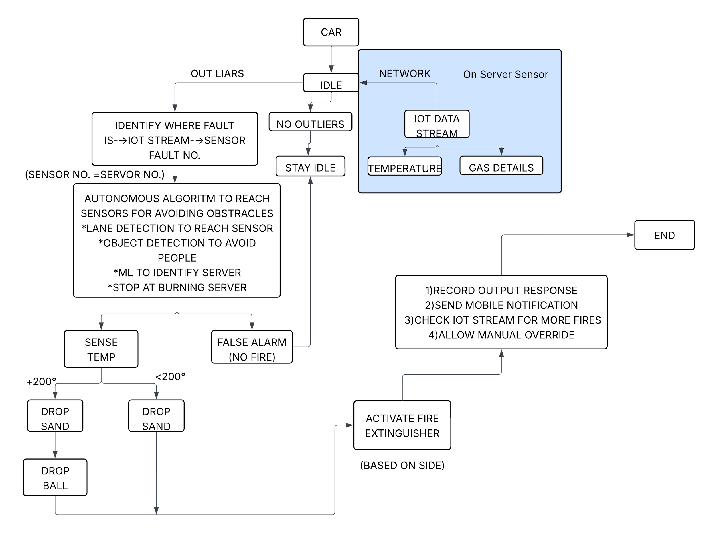
Figure 3.1: Algorithm Flow diagram

3.2 Hardware description:
This flowchart illustrates the electronic system architecture of an autonomous robot. Power from two 24V batteries is distributed and converted to supply various components, including an On-Board PC, a NodeMCU, and an Arduino. The Arduino controls the driving motors, while the NodeMCU manages peripherals like cameras, servos for a ball dropper, and extinguisher motors, forming an integrated system for autonomous operation.
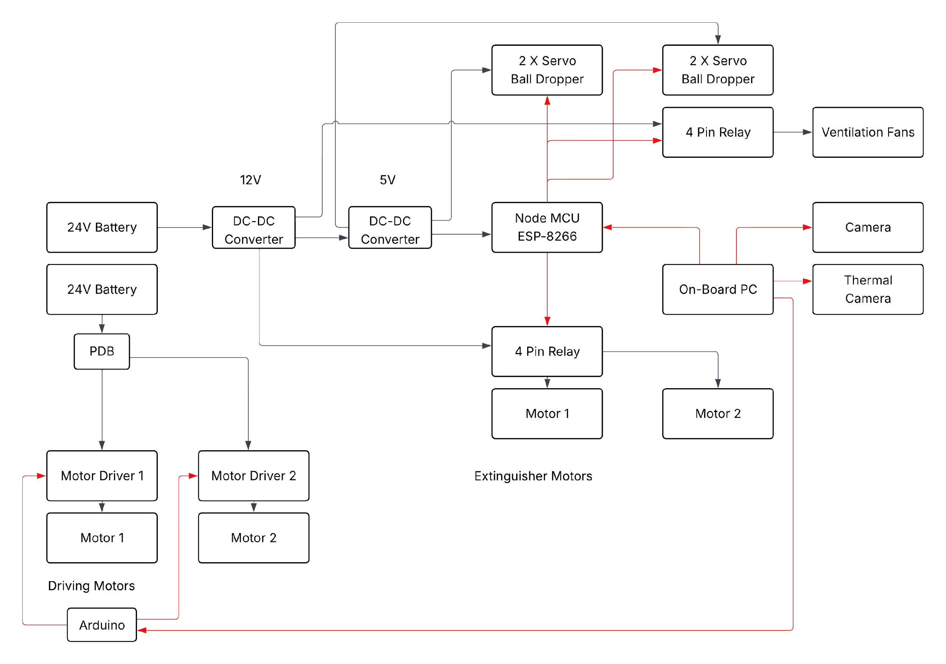
Figure 3.2: Circuit Block Diagram
Figure : Hardware and dataflow diagram

LIST OF COMPONENTS:
1) Motor-120RPM Brushed DC- Planetary Geared: This motor provides the necessary torque and controlled speed to drive the wheels of the robotic platform.
Core Principle: This is a motor designed for strength, not speed.
Brushed DC: This is a classic, robust motor type. It runs on DC (battery) power. Inside, "brushes" (small carbon blocks) make physical contact with a spinning part (the commutator) to reverse the current and keep the motor turning. It's simple, reliable, and provides high torque from a standstill.
Planetary Geared: This is the key. A high-speed, low-torque motor is fed into a "planetary" gearbox. This system has a central "sun" gear, several "planet" gears revolving around it, and an outer "ring" gear. This setup is compact and strong, and it performs gear reduction. It trades the high speed (e.g., 10,000 RPM) of the small motor for high torque (rotational force) at a much slower speed (120 RPM).
Use in our Bot:
This motor is the "muscle" of your robot's drivetrain. Your bot has a heavy payload of over 65 kg, including extinguishers, sand, and electronics. These high-torque motors are essential to provide the raw power needed to move this entire mass, especially from a dead stop. The slow, controlled 120 RPM speed is a feature, not a bug: it allows for the precise, steady navigation required to move through the confined spaces of a server room without lurching or spinning its wheels.

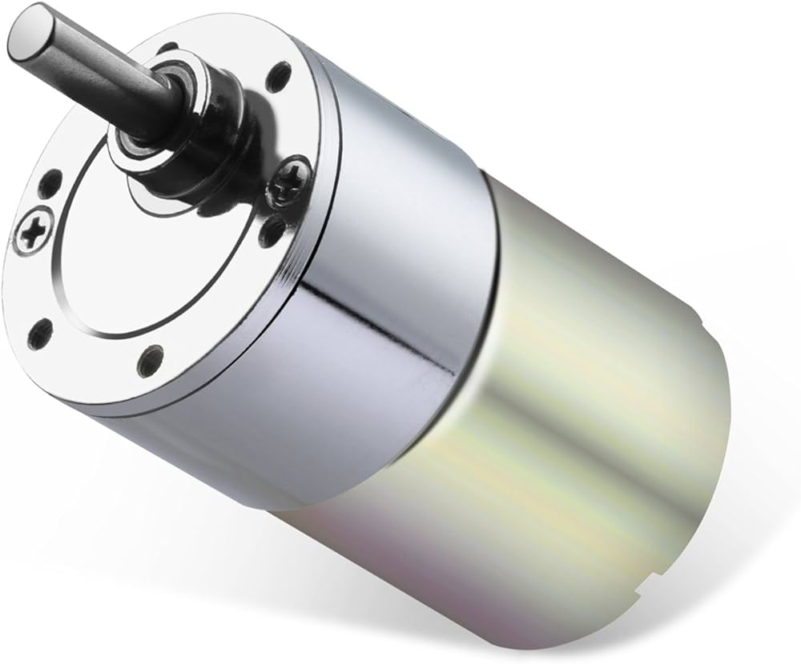

2) MD20A: This is a motor driver that receives signals from the Arduino to control the speed and direction of the DC motors.
Core Principle: This is a high-power electronic switch that acts as the bridge between the robot's "brain" and its "muscles." The Arduino's processor pins can only output a tiny signal (e.g., 5 Volts, 20 milliamps). This is not enough to run the high-power motors.
H-Bridge: At its core, the driver uses a circuit called an "H-Bridge." This allows it to reverse the polarity (direction) of the power going to the motor, making it spin forward or backward.
PWM Control: It controls the motor's speed using Pulse Width Modulation (PWM). Instead of sending a lower voltage, it "chops" the full 24V power, turning it on and off thousands of times per second. A "50% duty cycle" (on half the time, off half the time) makes the motor spin at half speed.
Use in our Bot:
You have two of these drivers, one for each motor. The Arduino sends two simple, low-power signals to each MD20A: a direction signal (forward/reverse) and a PWM signal (speed). The MD20A then takes this command and delivers the high-power 24V electricity (drawn from the main batteries) to the motors to execute the move.

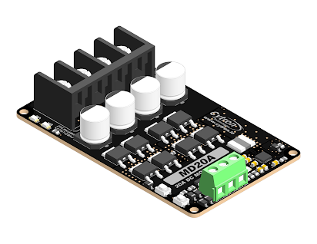

3) Arduino UNO: A microcontroller used for real-time, low-level hardware control, specifically managing the robot's motors via the motor drivers.
Core Principle: The Arduino is a microcontroller, not a microprocessor (like the CPU in your PC). It's a small, self-contained computer on a single chip, designed for real-time control. This means it can execute commands with precise, predictable timing (down to the microsecond). It doesn't have an operating system like Windows or Linux that can interrupt its tasks.
Use in our Bot:
The Arduino acts as a subordinate processor or "spinal cord" dedicated to one job: motion. It receives high-level commands from the main Onboard Computer (e.g., "move forward 1 meter," "rotate 30 degrees"). The Arduino then translates this one command into the hundreds of continuous, precisely-timed PWM signals that the MD20A motor drivers need to make the wheels spin perfectly. This division of labor is a robust design: the "brain" (Onboard PC) thinks, and the Arduino acts.
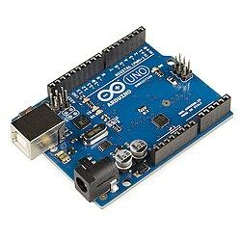

4) Node MCU(ESP8266): A microcontroller with built-in Wi-Fi used for network communication and controlling peripheral components like servos and relays.
Core Principle: This is also a microcontroller, but its key feature is the ESP8266 Wi-Fi chip. This low-cost chip allows the device to connect to a Wi-Fi network and communicate over the internet, making it the perfect component for Internet of Things (IoT) projects.
Use in our Bot:
This is your robot's communications and auxiliary control hub.
1. Communications: It connects to your network and "monitors [the] IoT data stream". This is how the bot "listens" for alerts from the "On Server Sensor" array (temperature, gas details) as part of the ANALYZE stage.
2. Control: As shown in the hardware diagram, it also controls all the robot's tools (everything except driving). It sends signals to the servos (to drop sand/balls) and to the 4-channel relay (to trigger fans/extinguishers).
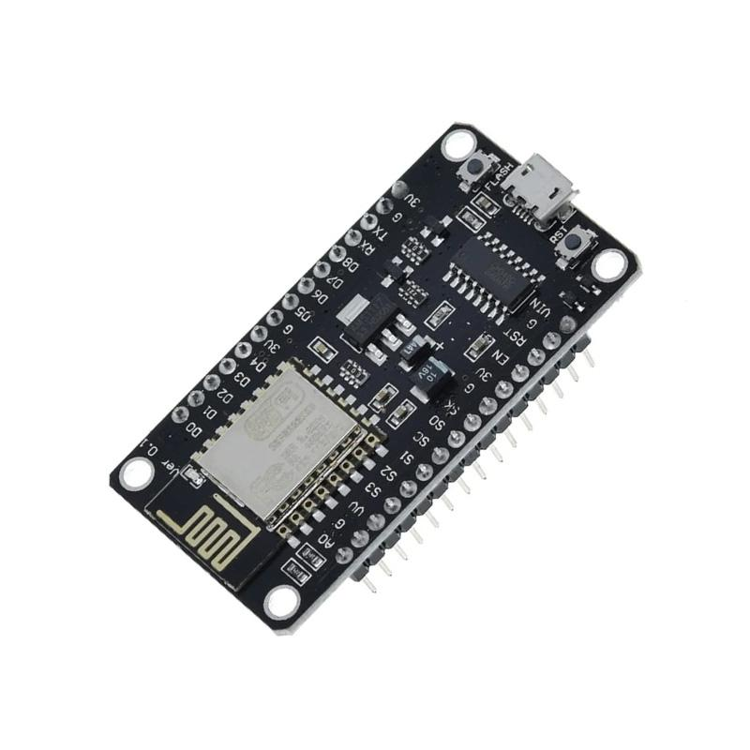

5) MG996R Servo: A high-torque servo motor used to actuate the release mechanisms for the sand and fire extinguishing balls.
Core Principle: A servo is a special motor for precision positioning. Inside is a DC motor, a gear train, a potentiometer (position sensor), and a control circuit. It's a closed-loop system: you send it a signal to go to a specific angle (e.g., 90 degrees), and its internal circuit will power the motor until the potentiometer reports that it has reached 90 degrees, and then it will actively hold that position. "High-Torque" means its gearbox is strong enough to move a heavy load.
Use in our Bot:
This is the physical actuator for your suppression systems. This servo provides the mechanical force to pull a pin, rotate a latch, or open a chute to release the sand and fire extinguishing balls. The hardware diagram shows two servos for the "Ball Dropper", likely to control two separate release mechanisms.
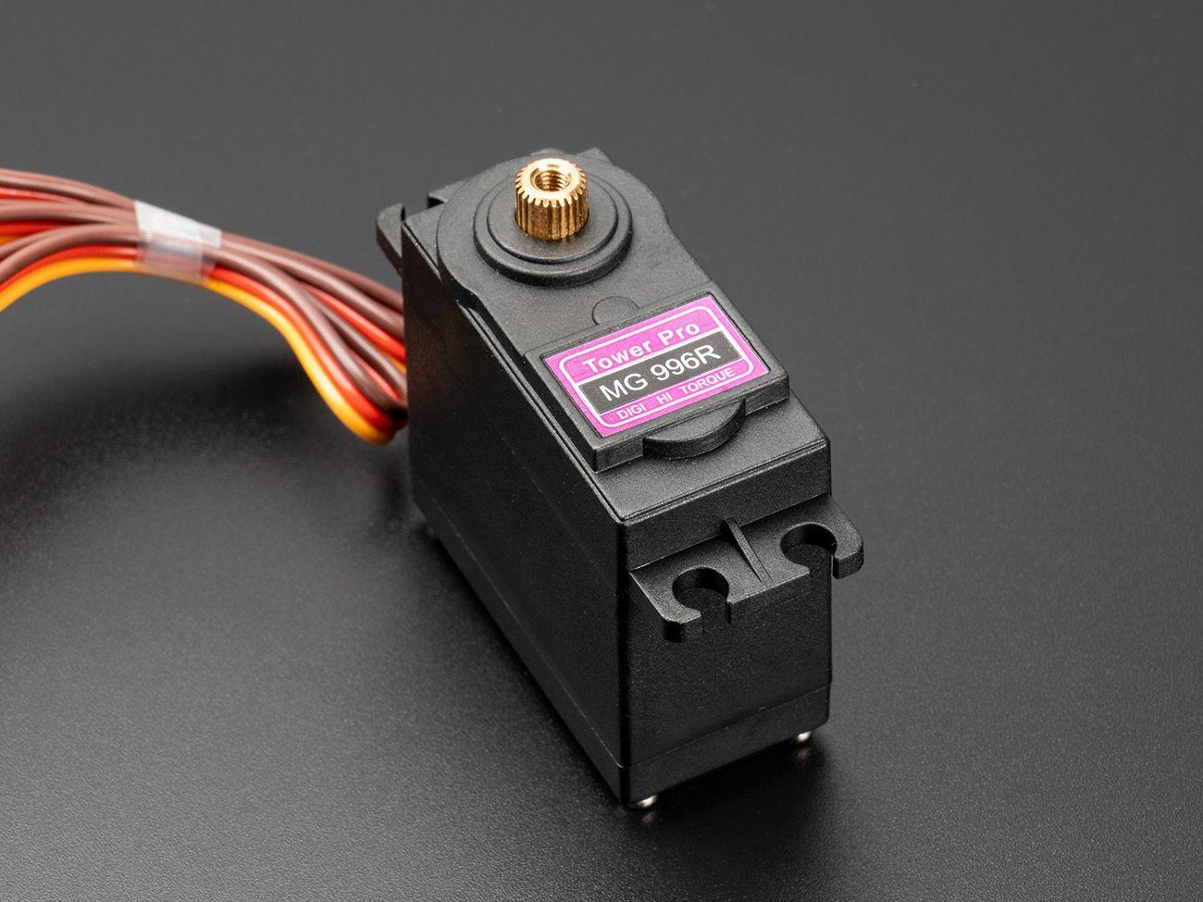

6) 3 CELL LIPO BATTERY: A lightweight, rechargeable power source that supplies electrical energy to the robot's various electronic components.
Core Principle: "LiPo" (Lithium Polymer) is a battery chemistry prized in robotics for its high energy density—it packs a lot of power into a light, small package. "3 Cell" means three 3.7V cells are connected in series (3S), creating a nominal voltage of 11.1V.
Use in our Bot:
Your hardware diagram shows two main 24V Batteries and a PDB (Power Distribution Board). This 24V source is ideal for the high-power motors. The 3-Cell (11.1V) battery is likely a separate, clean power source for the sensitive electronics. Alternatively, and more likely based on the diagram, the DC-DC Converters step down the main 24V supply to the various voltages needed by other components, such as 12V for the Onboard PC and 5V for the microcontrollers (Arduino/NodeMCU).
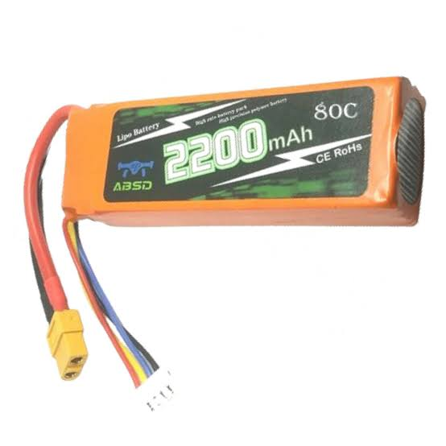

7) ONBOARD COMPUTER: The central processing unit that runs the AI, processes data from the stereo camera, and makes high-level autonomous decisions.
Core Principle: This is the robot's "main brain". It's a full-fledged, powerful computer (like an NVIDIA Jetson or Intel NUC) with a fast CPU and, critically, a GPU (Graphics Processing Unit). A GPU is essential for modern AI because its "parallel" architecture can perform thousands of calculations at once—perfect for running the neural networks used in machine learning.
Use in our Bot:
This computer does all the heavy computing. It runs the "autonomous algoritm" (likely ROS - Robot Operating System). It takes the 3D data from the ZED camera, performs "ML to identify [the] burning server", detects obstacles, and plans the safest path. It makes all the high-level decisions and then sends simple commands to its subordinates: the Arduino ("move") and the NodeMCU ("act").

8) ZED-2I STEREO CAMERA: An advanced depth-sensing camera that provides the robot with visual data for navigation, obstacle avoidance, and environment mapping.
Core Principle: This is an advanced 3D vision sensor. "Stereo" means it uses two lenses, like human eyes. Its internal software finds the same point in both the left and right images. By measuring the tiny difference in their positions (called disparity), it can triangulate the 3D (X, Y, Z) position of every pixel in the scene, creating a "depth map."
Use in our Bot:
This is the robot's primary "eyes" for navigation. The Onboard Computer uses this 3D depth data for "lane detection to reach sensor" and "object detection to avoid people". This is what allows the bot to map its environment and navigate autonomously without crashing. Your hardware diagram also lists a separate "Thermal Camera", which is a key part of your multi-sensor approach—the ZED-2i is for navigation, and the thermal camera is for fire confirmation.
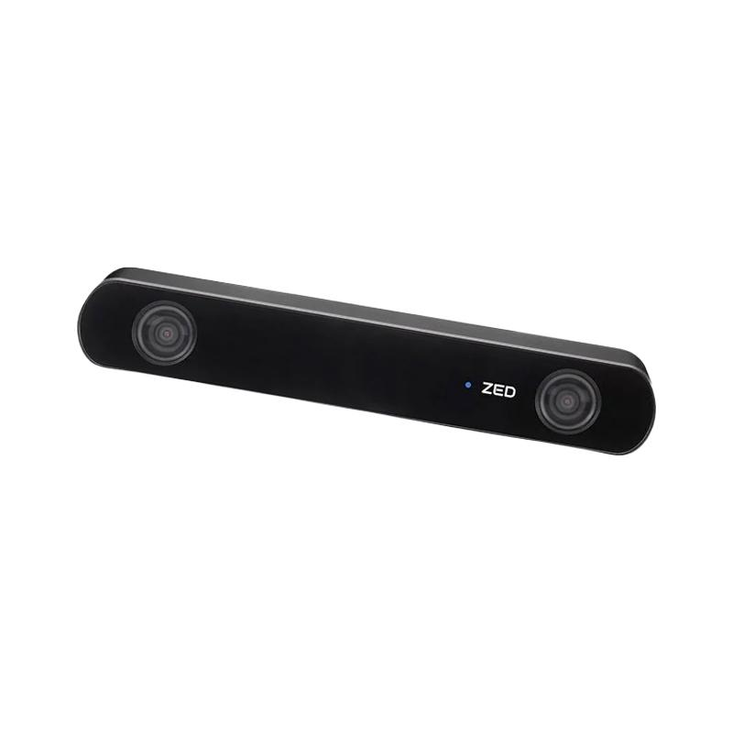

9) 7000RPMS SERVER FAN: A high-speed fan used for active cooling of the onboard computer and other electronics to prevent overheating.
Core Principle: A high-speed, high-airflow fan designed for reliability. 7000 RPM is extremely fast, allowing it to move a large CFM (Cubic Feet per Minute) of air. It uses durable ball bearings to sustain this speed for thousands of hours.
Use in our Bot:
This is a mission-critical support component. Your Onboard Computer generates intense heat from its "heavy computing load" (running AI and 3D video processing). Furthermore, the robot is designed to operate in a high-heat environment near a fire. This fan provides active cooling to pull cool air in and exhaust hot air, preventing the "brain" from "thermal throttling" (slowing down to protect itself) or shutting down at the worst possible moment.
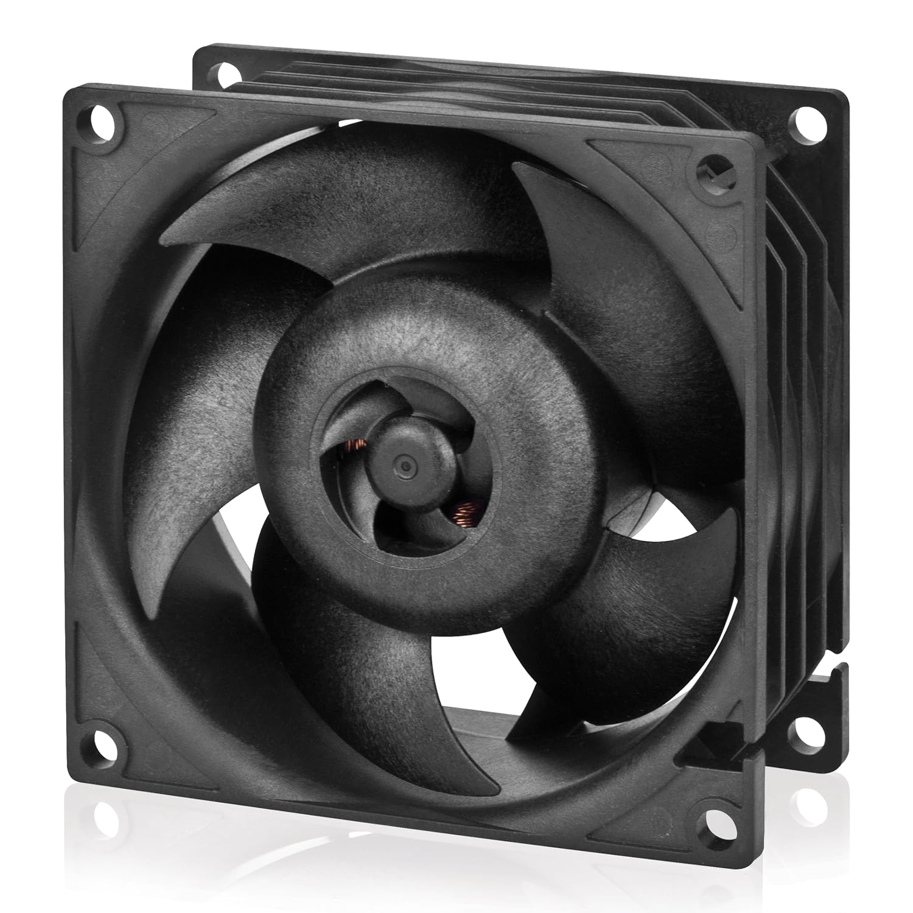

10) 4 CHANNEL RELAY: An electrically operated switch used by the NodeMCU to control higher power components like the ventilation fans and motors.
Core Principle: A relay is an electrically isolated switch. It uses a small, safe current (from the NodeMCU) to power a tiny electromagnet. This magnet physically pulls a metal lever, closing a separate, high-power circuit. This allows your 5V microcontroller to safely control 24V (or 240V) devices without them ever touching electrically. "4 Channel" just means you have four of these switches on one board.
Use in our Bot:
This is the power-switching hub for the robot's high-power tools. As shown in the diagram, the NodeMCU sends signals to this relay to turn on/off:
• Ventilation Fans (the 7000RPM fans).
• Motors / PDB Power: It also appears to switch power to the motor drivers and On-Board PC, acting as a master "on/off" switch for the robot's main systems.
• Extinguisher Motors: It would also be used to trigger the "extinguisher motors" that activate your main CO₂/DCP extinguisher, as this would require a high-power signal.
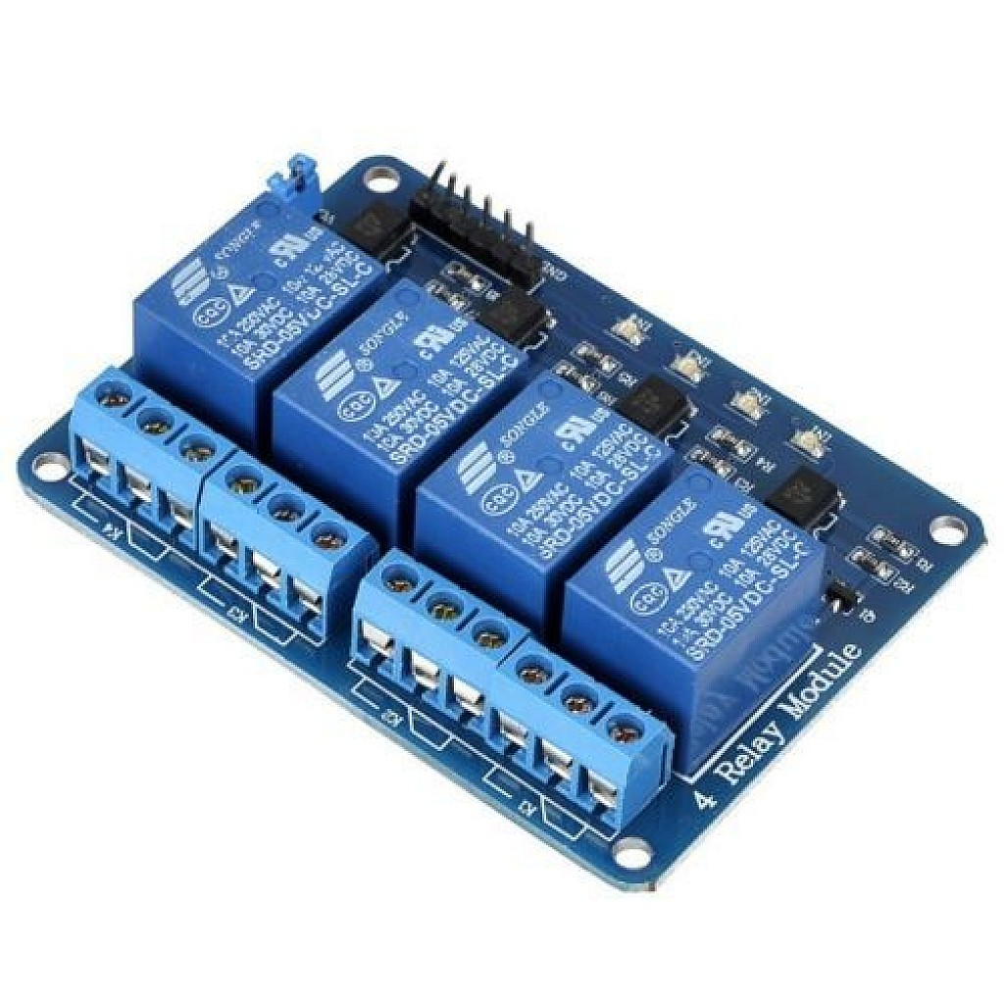

3.3 Software Description
The software architecture of the Autonomous Fire-Extinguishing Robot is developed using the Robot Operating System (ROS) as its core communication and coordination framework. ROS enables seamless interaction between various modules of the robot—ranging from perception and control to networking and actuation—ensuring that every component works in synchronization.
The software system is broadly divided into three main modules:
- Vehicle Control Module
- Dashboard and Network Interface
- Sensing and Fire Detection Module
Each module performs specific functions yet remains interconnected through ROS topics, services, and nodes, forming a cohesive and efficient control ecosystem.

Vehicle Control Module
The Vehicle Control Module forms the brain of the robot’s movement system. It is primarily responsible for autonomous navigation, decision-making, and obstacle avoidance.
The onboard computer continuously receives a stereo video feed from the ZED Stereo Camera, which provides both visual and depth information about the surrounding environment. Using OpenCV, the system processes these frames to detect lane markings, boundaries, and potential obstacles. Through this vision-based approach, the robot can identify the correct path and stay centered within its lane.
The image processing algorithms calculate deviations from the desired path and generate appropriate control commands. These commands—such as turning, accelerating, or stopping—are published via ROS topics and sent to the motor controller, which adjusts the robot’s movement in real time.
Obstacle avoidance is achieved through depth estimation and object recognition. The stereo camera allows the robot to measure distances to objects and detect humans or obstacles in its route. If an obstruction is detected, the system computes an alternate path or temporarily halts the motion to prevent collision.
Together, these capabilities enable the robot to navigate autonomously within structured environments, follow lanes smoothly, and respond intelligently to changing conditions, all without requiring manual intervention.

Dashboard and Network Interface
The Dashboard and Network Interface module provides a user-friendly way to interact with and monitor the robot. It is powered by a NodeMCU microcontroller, which establishes a dedicated Wi-Fi access point for the robot. This allows the creation of a local web dashboard accessible from any device connected to the same network.
The dashboard acts as the central control and feedback hub. Through this interface, operators can manually control key components such as the cooling fans, sand-dropping unit, and fire-extinguishing ball system. These controls can be toggled individually or activated as part of a coordinated response, depending on the situation.
In addition to control features, the dashboard displays real-time data from various onboard sensors, including temperature and gas readings. It also integrates the live video feed from the ZED Stereo Camera, allowing the user to visually monitor the robot’s surroundings and movement.
ROS ensures reliable communication between the main processing unit and the NodeMCU, maintaining synchronization across all systems. Commands from the dashboard are transmitted as ROS messages, while feedback and sensor data are continuously published to the network.
This setup allows for both autonomous and semi-manual operation, giving flexibility during testing or emergency conditions. It not only enhances usability but also improves system reliability by enabling human supervision over critical operations.

Sensing and Fire Detection Module
The Sensing and Fire Detection Module is the critical component responsible for identifying potential fire hazards and triggering the robot’s firefighting mechanism. It integrates multiple sensors and intelligent decision-making algorithms to continuously monitor the environment and respond to any signs of danger.
This module primarily uses temperature sensors and gas sensors placed strategically around the robot’s body. The gas sensors detect the presence of combustible gases or smoke particles, while the temperature sensors track any sudden rise in ambient heat levels. These sensors are interfaced with the ROS network and periodically publish their readings as ROS topics to the main processing node.
The data from these sensors are constantly analyzed in real time. When the system detects abnormal readings—such as a spike in temperature or a significant concentration of flammable gases—it flags a potential fire condition. Upon confirming this event, the robot transitions from its normal patrolling mode to fire response mode.
In this mode, the robot utilizes its camera vision (from the ZED Stereo Camera) and OpenCV-based object recognition to visually locate the fire source or a designated fire marker within its environment. Once the target is identified, the Vehicle Control Module takes over to autonomously navigate the robot toward the affected area with precision and safety.
After reaching the source, the robot automatically activates its three-stage fire suppression system, which includes:
- Air Cooling Stage – High-speed fans are turned on to blow air toward the fire, reducing surface temperature and slowing flame spread.
- Sand Dropping Stage – The robot releases sand onto the target area to cut off the fire’s oxygen supply and prevent reignition.
- Fire-Extinguishing Ball Deployment – Finally, specialized fire-extinguishing balls are released, dispersing a dry chemical powder that neutralizes the remaining flames effectively.
Throughout this entire process, sensor data and system status are updated continuously on the dashboard, allowing the operator to monitor progress and intervene manually if needed. This closed-loop sensing and control design ensures that the robot can detect, approach, and extinguish a fire autonomously, minimizing human risk and maximizing operational efficiency.

Chapter 4: Results And Analysis
This chapter provides a thorough evaluation of the project, detailing the validation of the prototype, analysis of its performance, and a discussion of the study's contributions. The results logically lead to conclusions about the system's feasibility and outline the scope for future work.
Prototype Development and Testing Environment
To validate the theoretical model, a fully functional physical prototype was constructed. The prototype was designed to be
compact and maneuverable, ensuring its ability to operate effectively within the confined spaces of a server room or laboratory. Rigorous testing was conducted in a
simulated environment created to safely replicate the conditions of a fire hazard in a high-value electronic area. This controlled setting allowed for the consistent and repeatable validation of the bot's entire four-stage operational cycle
Performance Validation and Metrics
The prototype's performance was measured against key indicators to validate its design and functionality. The following results were achieved:
- Detection Speed: In the simulated environment, the bot successfully detected smoke and gas in less than 10 seconds. This response time is significantly faster than typical human intervention.
- Precision Response: The extinguishing arm's precision was validated, confirming its ability to deploy an agent directly onto a target with an accuracy of within 50 cm. We are validating the precision of the extinguishing arm to confirm its ability to deploy the agent with high accuracy.
Throughout the implementation phase, key technical challenges were successfully addressed. These included managing the
heavy computing load in a high-heat environment where thermal throttling is possible and ensuring the heavy payload carrying capacity of over 65 kg
Adherence to Testing Standards
For an engineering project's results to be valid, they must be tested against established industry standards. While the initial validation focused on the core functionalities, a complete report must ensure compliance with relevant standards. Potentially applicable standards for this project include:
- NFPA 75: This is the Standard for the Fire Protection of Information Technology Equipment and is critical for the project's application domain. Testing would need to align with the safety requirements for IT environments.
- IEEE 1872-2015: This is the Standard for Autonomous Robotics (AuR) Ontology and provides a framework for defining the knowledge required for autonomous robot operation.
- IEEE 802.11 Standards: Since the bot relies on wireless communication, its protocols must be tested for reliability and security in accordance with the relevant Wi-Fi standards

Chapter 5: Advantages, Limitations and Applications

5.1 Advantages
The intelligent and autonomous design of the system offers several key advantages over traditional fire suppression methods:
- Prevents Collateral Damage: The system's primary benefit is its ability to extinguish fires using a clean, non-damaging agent with high precision. This protects sensitive, high-value electronic equipment from the catastrophic damage caused by traditional water-based systems.
- Proactive and Predictive Capability: Unlike purely reactive systems, the bot uses proactive analysis of real-time data to monitor for overheating components or unusual temperature spikes, identifying potential fire hazards before a fire even starts.
- Rapid and Precise Response: The system demonstrated a detection speed of less than 10 seconds and a deployment accuracy of within 50 cm. This combination of speed and precision allows it to neutralize a threat in its earliest stages, minimizing potential damage.
- High Reliability and Low False Positives: By utilizing a fusion of multiple sensors (thermal, smoke, and gas), the system accurately confirms that a credible threat is present before taking action, which minimizes the risk of false positives.
- Data-Driven Insights for Improvement: The system logs all incident data to a central dashboard, providing crucial information for post-incident analysis. This addresses a key gap in existing solutions, which often fail to provide comprehensive data logs for future prevention.
Enhanced Safety and Operational Continuity: By providing a solution that is automated, precise, and safe, the system fills a critical market gap and helps maintain operational continuity in mission-critical facilities.

5.2 Limitations
While the prototype has successfully validated the core concept, it is important to acknowledge the limitations of the current design, which provide a clear direction for future work.
- Finite Extinguishing Capacity: The bot carries a limited onboard supply of the extinguishing agent. This makes it highly effective for early-stage intervention and localized fires, but it may be insufficient for larger, rapidly escalating blazes.
- Scalability for Large Areas: A single bot has a finite operational range. Protecting large-scale facilities, such as hyperscale data centers, would require a multi-bot system, which introduces challenges in coordination and management.
- Complex Obstacle Navigation: Although equipped with navigation sensors, the current prototype may be challenged by complex or unexpected obstacles, such as fallen debris or tangled cabling, which could impede its path to a fire.
Dependency on Power: As an electromechanical system, the bot is dependent on its battery. A robust power management strategy, including a fail-safe return-to-charge protocol, is critical for ensuring its readiness and reliability.

5.3 Applications
The system is ideally suited for deployment in any sensitive environment where the use of water or other indiscriminate suppression agents would be destructive, expensive, or disruptive. The primary application areas include:
- Data Centers and Server Rooms: This is the core application, protecting the mission-critical IT equipment that supports industries like finance, healthcare, and IT.
- Telecommunication Hubs: Safeguarding network switches, routers, and other vital communication hardware.
- Medical and Scientific Laboratories: Protecting expensive diagnostic and research equipment from both fire and water damage.
- Industrial Control Centers: Securing the control rooms for manufacturing plants, power grids, and other critical infrastructure.
- Museums, Archives, and Libraries: Preserving irreplaceable artifacts, historical documents, and collections where water damage would be catastrophic.
- Semiconductor Fabrication Plants: Operating in cleanroom environments where contamination from conventional extinguishing agents is unacceptable.

Chapter 6: Conclusion and Future Scope

6.1 Conclusion
This project was initiated to address the critical problem of catastrophic collateral damage caused by traditional fire suppression systems in sensitive electronic environments. To solve this, the project successfully designed, developed, and validated an intelligent, autonomous robotic system that operates on a comprehensive four-stage cycle of prediction, detection, response, and reporting. The development process culminated in a fully functional physical prototype that was subjected to rigorous testing in a simulated environment.
The analysis of the test results leads to the definitive conclusion that the proposed system is a feasible and highly effective solution. The prototype's ability to
detect threats in under 10 seconds and deploy a clean agent with an accuracy of within 50 cm validates its capability to perform rapid, precise, and non-damaging fire suppression. This work successfully presents a proof-of-concept that directly addresses the "Black or White" problem in the fire safety market, providing a solution that is
automated, precise, and safe. Ultimately, the system demonstrates a new standard in fire safety, capable of protecting high-value assets while ensuring operational continuity in critical infrastructure.

6.2 Future Scope
Based on the successful validation of the prototype, the following areas have been identified for future research and development to enhance the system and move it towards commercial viability:
- Advanced AI Modeling: The predictive capabilities of the AI can be significantly enhanced by training the models with larger and more diverse datasets from real-world operational environments.
- Expanded Testing Scenarios: Future work should include validating the bot's effectiveness against different classes of fire (e.g., chemical, electrical) and in more complex physical environments with dynamic obstacles.
- Hardware Optimization: The bot's physical design can be further optimized through miniaturization to access more confined spaces and enhancement of its payload capacity to carry different or larger volumes of extinguishing agents.
- System Integration: The bot's reporting dashboard should be integrated with existing Building Management Systems (BMS) and emergency alert systems for a seamless, unified safety infrastructure.
- Multi-Bot Coordination (Swarm Intelligence): Developing swarm intelligence algorithms would enable a fleet of bots to work collaboratively, providing coordinated and scalable fire protection for large-scale facilities like hyperscale data centers.
- Formal Certification: A critical next step is to pursue formal testing and certification of the system against key industry standards, such as NFPA 75 (Standard for the Fire Protection of Information Technology Equipment) and relevant IEEE standards, to ensure its reliability and safety for commercial deployment

References
[1] C. Bhawana, V. Thota, and S. Bachu, "Artificial Intelligence based Wheeled Fire Fighting Robot with A Fire Extinguishing, Ball-Shooting Turret for Forest Areas," in 2024 International Conference on Social and Sustainable Innovations in Technology and Engineering (SASI-ITE), 2024, pp. 198-202. doi: 10.1109/SASI-ITE58663.2024.00042.
[2] A. Z. M. T. Kabir et al., "IoT Based Low Cost Smart Indoor Farming Management System Using an Assistant Robot and Mobile App," in 2020 Electrical Power, Electronics, Communications, Controls and Informatics Seminar (EECCIS), 2020, pp. 155-158.
[3] M. P. Suresh et al., "An Arduino Uno Controlled Fire Fighting Robot for Fires in Enclosed Spaces," in 2022 Sixth International Conference on I-SMAC (IoT in Social, Mobile, Analytics and Cloud) (I-SMAC), 2022, pp. 398-402. doi: 10.1109/I-SMAC55078.2022.9987432.
[4] R. Sreekanth, R. B. M, T. S. Aiswarya, and N. Harini, "Agribot - A Multifunctional Autonomous Robot for Enhanced Agricultural Efficiency and Precision Farming," in
2025 International Conference on Frontier Technologies and Solutions (ICFTS), 2025, pp. 1-7. doi: 10.1109/ICFTS62006.2025.11031932.
[5] P. Manikandan, P. Babu, B. SasiKumar, and G. Shanmugam, "SEEDS SOWING ROBOT IN AGRICULTURE USING IOT," in 2025 3rd International Conference on Artificial Intelligence and Machine Learning Applications Theme: Healthcare and Internet of Things (AIMLA), 2025, pp. 1-5. doi: 10.1109/AIMLA63829.2025.11041118.
[6] T. L. Chien, J. H. Guo, K. L. Su, and S. V. Shiau, "Develop a Multiple Interface Based Fire Fighting Robot," in Proc. Int. Conf. Mechatronics, Kumamoto, Japan, 2007, pp. 1-6.

Appendix

